HPLC, TLC Characterization of Rutin and its exploration of In vitro antioxidant, anti-inflammatory and antimicrobial potential


SUMMER INTERNSHIP REPORT
(5th June-5th August)
By
ANUSKA SARKAR
(Roll- 2156020)
(Autonomy roll- 12621004010)
(Year: 4th) (Sem: 7th)

Under the guidance of,
Prof. Sanmoy Karmakar,
Department of Pharmaceutical Technology,
Jadavpur University, Kolkata.
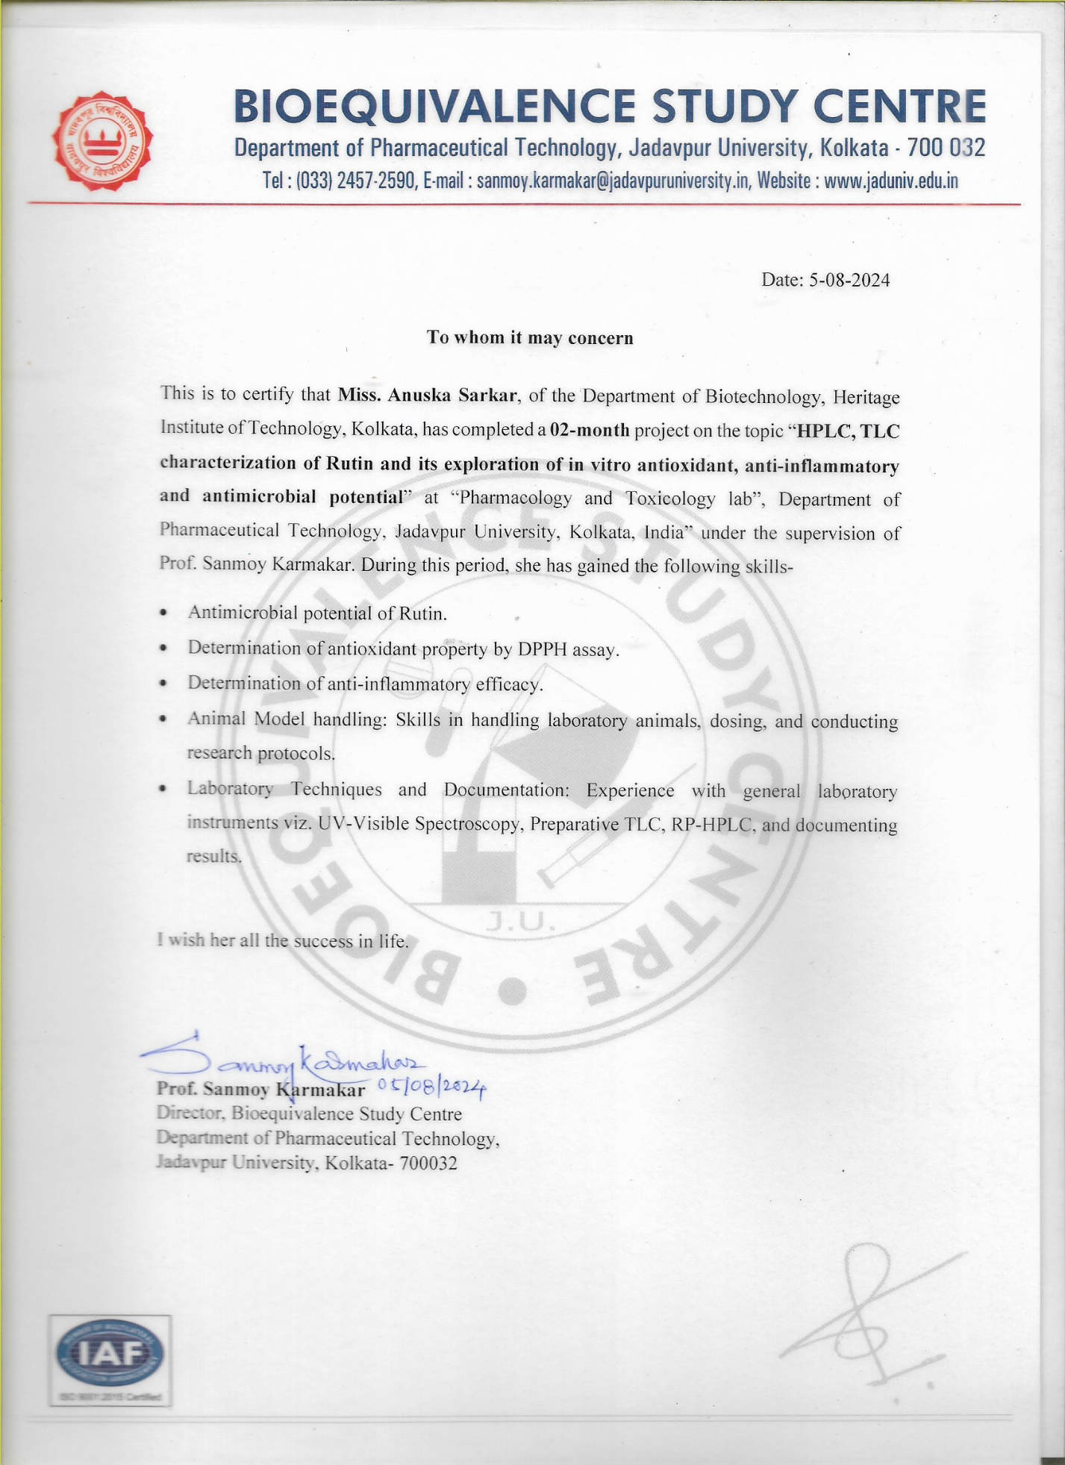

Declaration

I hereby declare that the project titled “HPLC, TLC Characterization of Rutin and its exploration of In vitro antioxidant, anti-inflammatory and antimicrobial potential,” submitted to Jadavpur University has been carried out by me under the supervision of Prof. Sanmoy Karmakar. This project was undertaken between 5th June and 5th August, 2024. All the work conducted and presented in this project is my original work, and any references to other works have been duly cited.

Name: Anuska Sarkar
Department: Pharmaceutical Technology
University: Jadavpur University
Date: 05.08.2024

Acknowledgment

Flavonoids are an important group of plant phytocompounds with great pharmaceutical importance as an Active Pharmaceutical Ingredient. As such, I am grateful to Prof. Sanmoy Karmakar and Jadavpur University to give me this opportunity to explore the various functionalities of these compounds with such research potential.
I would also like to thank my M.Pharm seniors and research scholars for their constant guidance and navigation throughout the internship period. Interacting with them converted my internship journey into a fun learning experience allowing me to obtain deeper understanding of the Lab and all it’s instruments as well as the experiments that were conducted.
Overall, the opportunity to apply theoretical knowledge into real-life situation was a necessary eye opener required for bachelor students such as myself. This has opened up multiple opportunities for me ahead in the future.
I would like to give special thanks to Ph.D scholars Arnab Sarkar, Akash De and Ankita Das for their support.

Table of Contents

Objective and Plan of work …………………………………………………. 7
1. Good Laboratory Practices........................................................................... 8-9
2. Introduction
2.1 Flavonoids………………………………………………………… 10
2.2 Rutin trihydrate................................................................................ 11
2.3 Activities Observed in Rutin Trihydrate........................................... 12
3. Laboratory Instruments
3.1 Pipette.............................................................................................. 13
3.2 Vortex............................................................................................... 14
3.3 UV-Vis Spectrophotometer.......................................................... 15-16
3.4 Milli-Q............................................................................................. 17
3.5 pH meter........................................................................................... 17
3.6 Double Distillator............................................................................. 18
3.7 Homogenizer and Ultrasonicator...................................................... 19
3.8 Cooling Microcentrifuge.................................................................. 20
3.9 Soxhlet extractor............................................................................... 21
3.10 Photo Diode Array........................................................................... 22
3.11 Water Bath....................................................................................... 23
3.12 TLC Viewing Cabinet..................................................................... 24
4. Chromatographic Techniques....................................................................... 25
4.1 TLC (Thin Layer Chromatography) ............................................ 26-27
4.2 HPLC (High-Performance Liquid Chromatography) ................. 28-29

5. Serial Dilution of Rutin Trihydrate............................................................... 30
6. Antioxidant Effect of Rutin Trihydrate.................................................... 31-33
7. Anti-inflammatory Effect of Rutin Trihydrate......................................... 34-35
8. Antimicrobial Effect of Rutin Trihydrate................................................. 36-42
9. Conclusion..................................................................................................... 43
10. References................................................................................................... 44

Objective
and
Plan of work

This project aims to analyze the purity and identification of Rutin trihydrate, correspondingly studying its antioxidant, anti-inflammatory, and antimicrobial potential.
- Rutin trihydrate is a flavonoid, known for its antioxidant, anti-inflammatory and antimicrobial activities and thus is tested for the same.
- HPLC of Rutin trihydrate is performed at a concentration of 1mg/ml and its presence and purity is measured.
- TLC of Rutin is implemented and its presence and polarity is measured.
- Rutin is serially diluted in water and methanol respectively to check for its solubility and to prepare the stock solutions required.
- For antioxidant activity, serially diluted rutin in methanol is tested against DPPH, keeping Ascorbic acid as standard.
- For anti-inflammatory activity, serially diluted rutin in PBS buffer is tested against BSA denaturation, keeping Diclofenac as standard.
- For antimicrobial activity, serially diluted rutin in water is tested against E.coli(Gram -ve) and B.subtilis(Gram +ve), using McFarland standard and examining their MIC and MBC.
- Every experiment is visualized under the UV Spectrophotometer and results are analyzed.
- Discussion on results.

- Good Laboratory Practices

Building a culture of quality and safety in the workplace goes beyond just having a set of how-to guidelines. It’s about fostering the right mindset among your workers so that safety becomes second nature to them. One way to do so is through GLP training.
The Principles of Good Laboratory Practice (GLP) establish rules and criteria for a quality system that oversees the organizational processes and conditions in which non-clinical health and environmental safety studies are planned, conducted, monitored, recorded, reported and archived. These principles apply to the non-clinical safety testing of substances found in various products to ensure the quality and integrity of the safety data submitted to regulatory authorities globally; aim to ensure the quality and validity of data produced during chemical testing and deter fraudulent activities.
The guidelines were first introduced in New Zealand and Denmark in 1972, following the standards set by the OECD, and the EU has incorporated these guidelines and the updated OECD Guidelines for Monitoring GLP Compliance as additions to its two GLP Directives.
Below are general Good Laboratory Practice examples:
• Wear Personal Protective Equipment (PPE) at all times.
• Communicate with other members of the research lab.
• Participate in refresher training and safety exercises.
• Be aware of what you’re doing at all times.
• Pay attention to unfamiliar smells and substances.
• Use the right lab equipment for the task or activity.
• Regularly clean, calibrate, and maintain equipment.
GLP supports the recognition of test data between nations, preventing redundant testing, benefiting animal well-being, and cutting costs for both industry and governments. Shared principles for GLP also help with sharing information an avoiding trade barriers, while also safeguarding human health and the environment.
The 10 Good Laboratory Practice principles are:
1. Test Facility Organization and Personnel
2. Quality Assurance Programme
3. Facilities
4. Apparatus, Material, Reagents
5. Test Systems
6. Test and Reference Items
7. Standard Operating Procedures
8. Performance of the Study
9. Reporting of Study Results
10. Storage and Retention of Records and Materials
India has collaborated with the OECD in various areas like economic policy, corporate governance, anti-corruption, trade, and investment, benefiting from its large and fast-developing economy supported by structural reforms and strengths in key sectors like information technology, services, agriculture, and manufacturing. India takes part in specific OECD Committees and their related groups. The main goals of the OECD-India partnership include increasing productivity, promoting sustainable development, and improving connectivity, while also backing India's prominent position in the G20, especially during its leadership in 2023.

2.1. FLAVANOIDS
Flavonoids or (bioflavonoids), a group of natural substances with variable phenolic structures, are found in fruits, vegetables, grains, bark, etc. These natural products are well known for their beneficial effects on health and efforts are being made to isolate the ingredients so called flavonoids.
Flavonoids are hydroxylated phenolic compounds with a common benzo-Ɣ-pyrone structure. They are either found in free form(aglycones) or bound to a sugar(β-glycoside). The basic structure consists of 15-C atoms skeleton of 3 rings (A, B,C), two benzene rings and 1 Heterocyclic pyran ring as shown in Figure 1.1.
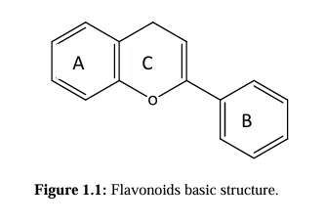
Due to their polyphenolic structure, they proved their role as antioxidants by acting as free radical scavengers for the ROS. Their potency and efficacy vary according to the number and position of OH groups in their structure, the degree of oxidation and unsaturation, and other substitutions and conjugations linked to their basic formula.
Flavonoids are now considered as an indispensable component in a variety of nutraceutical, pharmaceutical, medicinal and cosmetic applications. This is attributed to their anti-oxidative, anti-inflammatory, anti-mutagenic and anti-carcinogenic properties coupled with their capacity to modulate key cellular enzyme function and an added impulse with the discovery of the low cardiovascular mortality rate and also prevention of CHD.
2.2. RUTIN TRIHYDRATE
Rutin Trihydrate (rutoside, quercetin-3-O-rutinoside, or sophorin) is the glycoside combining the flavonol quercetin and the disaccharide rutinose (α-L-rhamnopyranosyl-(1→6)-β-D-glucopyranose). It is a citrus flavonoid glycoside found in the leaves and petioles of Rheum species and asparagus. Tartary buckwheat seeds have been found to contain more rutin (about 0.8–1.7% dry weight) than common buckwheat seeds (0.01% dry weight).
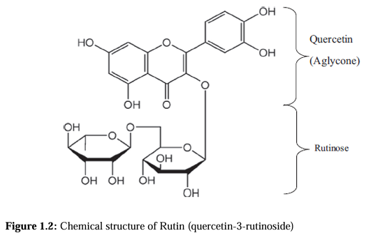
It has strong antimicrobial, antioxidant activity, anti-inflammatory effect, anti-hypertensive effects, strengthens the capillary vessel walls and reduces capillary fragility; therefore protecting it from various veins, hemorrhoids, etc. However, the absorption of rutin and quercetin from the gastrointestinal tract is slow and unreliable contributing to their low bioavailability.
Apparently, the larger the number of OH groups added to their basic structure, the higher the antioxidant and radical scavenging activity they have. The presence of ortho 3’,4’ dihydroxy substituents in the B ring greatly enhances their antioxidant potential.
The commercial product venoruton which contains a mixture of hydroxyethyl rutosides is found in the market and used in the treatment of chronic venous insufficiency and hypertension conditions. However, when one or more phenolic OH groups are blocked in a semi synthetic derivative of such a benzopyran glycoside, it greatly affects the activity of the compound.
2.3 ACTIVITIES OBSERVED IN RUTIN TRIHYDRATE

This study shows the antimicrobial, antioxidant and analgesic activities of Rutin Trihydrate.

Rutin has shown antibacterial effects against various bacterial strains in several studies. It has been reported to inhibit the growth of bacteria such as Staphylococcus aureus, Escherichia coli, Pseudomonas aeruginosa, and Bacillus subtilis. These effects are attributed to rutin's ability to disrupt bacterial cell membranes and inhibit bacterial enzymes necessary for their growth. The antimicrobial effects of rutin are primarily attributed to its ability to disrupt microbial membranes, inhibit microbial enzyme activities, and interfere with microbial DNA or RNA synthesis. These mechanisms contribute to its broad-spectrum antimicrobial activity against bacteria, fungi, and potentially viruses.

It is well-known for its antioxidant properties, acts as a potent antioxidant by scavenging free radicals and reactive oxygen species (ROS) in the body. Free radicals are unstable molecules that can cause oxidative stress and damage cells. Rutin's ability to neutralize these radicals helps protect cells from oxidative damage; which has been shown through the scavenging of the free radical of DPPH.

Flavonoids, including rutin, have been shown to modulate anti-inflammatory effects on the inhibition of denaturation of Bovine Serum Albumin(BSA). The drug prevents the protein BSA to not get denatured and thus not promoting inflammation.
3. Laboratory Instruments
3.1. PIPETTE
A pipette is a type of laboratory tool commonly used in chemistry and biology to transport a measured volume of liquid, often as a media dispenser. Pipettes come in several designs for various purposes with differing levels of accuracy and precision, from single-piece glass pipettes to more complex adjustable or electronic pipettes. Many pipette types work by creating a partial vacuum above the liquid-holding chamber and selectively releasing this vacuum to draw up and dispense liquid. Measurement accuracy varies greatly depending on the instrument.
Common pipettes:
- Air displacement micropipettes
- Electronic pipette
- Volumetric pipettes
- Graduated pipettes,etc.
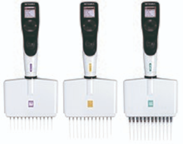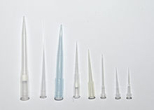
Fig.3: VIAFLO electronic multichannel Fig.4: A variety of pipette tips
pipettes from INTEGRA Biosciences
Posture and injuries:
- Winged elbow pipetting
- Over rotated arm pipetting
- Incorrect posture can have a strong impact on available strength arm strength pipetting

3.2. VORTEX MIXER
A vortex mixer, or vortexer, is a simple device used commonly in laboratories to mix small vials of liquid. It consists of an electric motor with the drive shaft oriented vertically and attached to a cupped rubber piece mounted slightly off-center. As the motor runs the rubber piece oscillates rapidly in a circular motion. When a test tube or other appropriate container is pressed into the rubber cup (or touched to its edge) the motion is transmitted to the liquid inside and a vortex is created. Most vortex mixers are designed with 2 or 4-plate formats, have variable speed settings ranging from 100 to 3,200 rpm, and can run continuously or only when downward pressure is applied to the rubber piece.
In cell culture and microbiology laboratories, they may be used to suspend cells. In a biochemical or analytical laboratory, they may be used to mix the reagents of an assay or to mix an experimental sample and a dilutant.
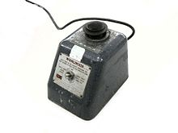 Fig.5: Vortex mixer
An alternative to the electric vortex mixer is the "finger vortex" technique in which a vortex is created manually by striking a test tube in a forward and downward motion with one's finger or thumb, it may be suitable in some cases when a vortex mixer is unavailable or the forces involved in vortexing would damage the sample. Still, this technique is not recommended when caustic substances are involved. The technique is better suited to accelerate the mixture of solutions that do not require the kinetic energy input needed to create suspensions.
For incubating applications, vortex mixers can employ precision temperature control at various mixing speeds which make them ideal for a wide variety of molecular biology applications including immunochemical reactions, enzyme and protein analysis, and microarray analysis.

3.3 UV-VIS SPECTROPHOTOMETER

UV-Vis spectroscopy is an analytical technique that measures the amount of discrete wavelengths of UV or visible light that are absorbed by or transmitted through a sample in comparison to a reference or blank sample. This property is influenced by the sample composition, potentially providing information on what is in the sample and at what concentration.
Light's energy level is tied to its wavelength, with shorter wavelengths packing more energy and longer wavelengths carrying less. To excite electrons in a substance, specific amounts of energy are required, which correspond to specific wavelengths.
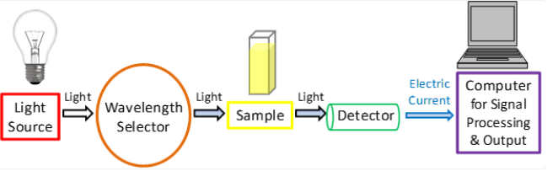
Fig.6: A simplified schematic of the main components in a UV-Vis spectrophotometer.
Working Principle:
1. Light Source: The spectrophotometer typically has a light source that emits a broad spectrum of light, including ultraviolet (UV) and visible wavelengths. Common light sources include tungsten lamps for visible light and deuterium lamps for UV light.
2. Monochromator: The emitted light passes through a monochromator, which is a device that separates the light into its individual wavelengths. This is done using a diffraction grating or prism. By adjusting the monochromator, we can select a specific wavelength of light to pass through the sample.
3. Sample Container: The sample to be analysed is placed in a transparent cuvette or sample cell. The sample cell is typically made of quartz or glass to allow light to pass through. The sample should be prepared in a way that it is transparent at the selected wavelength.
4. Detector: The light that passes through the sample is detected by a photodetector, which generates an electrical signal proportional to the intensity of the transmitted light.
5. Reference Cell: In some spectrophotometers, there is a reference cell that contains a solvent or blank solution. This is used to calibrate the instrument and account for any background absorption or scattering by the solvent. The reference cell is typically placed in a separate beam path and is used to measure baseline absorbance.
6. Measurement: The spectrophotometer measures the intensity of the transmitted light both for the sample and the reference. The ratio of the two measurements is used to calculate the absorbance (A) of the sample:
A = -log10(I sample / I reference) ,where,
- A is the absorbance of the sample. - I sample is the intensity of light transmitted through the sample.
- I reference is the intensity of light transmitted through the reference cell
7. Concentration Determination: The absorbance of the sample is then used to
determine the concentration of the analyte in the sample using Beer's law:
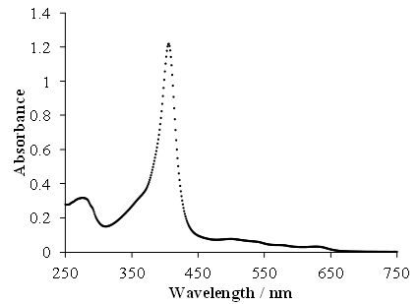
A = ε * c * l ,where, - A is the absorbance. - ε (epsilon) is the molar absorptivity (a constant specific to the analyte and wavelength). - c is the concentration of the analyte. - l is the path length of the sample cell (the distance the light travels)
Fig.7: An example absorption spectrum taken from a UV-Vis spectrophotometer

3.4. MILI-Q
Milli-Q® systems offer a unique combination of optimized water purification and monitoring technologies by using a 0.22µm filter. The selection of the proper type1 water system for your laboratory will depend on several parameters such as: feed water available, daily volume needs, monitoring requirements, certification levels expected and any other specific requirements you may have. This filtered water is free of ions because of an ion-exchange system, which is purer than double distilled water.
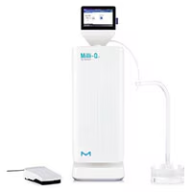 Fig.8: Milli-Q® IQ Element

3.5. pH METER
A pH meter is an instrument used to measure hydrogen ion activity in solutions - in other words, this instrument measures acidity/alkalinity of a solution.
This pH measurement is directly related to the ratio of hydrogen ion concentration and hydroxyl ion concentration ([H+] and [OH-], respectively), which generally ranges from 1 to 14. The general breakdown of pH levels is listed below:
Neutral solution: pH = 7; Acidic solution: pH < 7; Basic solution: pH > 7
A neutral solution will show a pH of 7 due to the equal activities of hydrogen and hydroxide ions. Acidic solutions exhibit pH readings below 7 (higher hydrogen ion activity compared to hydroxide ion activity), and basic (or alkaline) solutions exhibit pH levels above 7 (hydroxide ion activity is greater than that of hydrogen ion).
3.6. DOUBLE DISTILLATOR
It is a process used to obtain a highly purified or concentrated substance by performing two consecutive distillation steps. It is commonly employed in industries such as petroleum refining, chemical synthesis, and alcohol production.

Working Principle:
1. First Distillation: In the first distillation step, the liquid mixture is heated in a distillation apparatus, such as a distillation flask and a condenser. As the mixture is heated, the component with the lowest boiling point (the more volatile component) will vaporize first. These vaporized molecules rise through the distillation column or tube, leaving behind the less volatile components.
2. Condensation: The vaporized molecules then enter the condenser, where they cool down and condense back into liquid form. This condensed liquid, which is now enriched in the more volatile component, is collected in a separate container called the distillate
3. Collection of First Distillate: The first distillate is collected and set aside, leaving behind the residue and impurities that did not vaporize. However, even after the first distillation, the distillate may still contain some impurities or traces of other components.
4. Second Distillation: The first distillate is now subjected to a second distillation process. The same principles apply: the distillate is heated again, and the more volatile component will vaporize first. This time, the distillation is focused on separating the desired component from any remaining impurities.
5. Condensation and Final Collection: The vaporized molecules from the second distillation are condensed once again and collected as the final product. This distillate is expected to be purer than the distillate obtained from the first distillation, as it has undergone an additional separation.

3.7 HOMOGENISER AND ULTRASONICATOR
A homogenizer is a piece of laboratory or industrial equipment used for the homogenization of various types of material, such as tissue, plant, food, soil, and many others. More modern solutions are based on blender type instruments, bead mills, ultrasonic treatment (also sonication), rotor-stator mechanical, high pressure, and many other physical forces.
Cell fractionation is done by homogenizer to release the organelles from cell. Whereas older technologies just focused on the disruption of the material, newer technologies also address quality or environmental aspects, such as cross-contamination, aerosols, risk of infection, or noise. Homogenization is a very common sample preparation step prior to the analysis of nucleic acids, proteins, cells, metabolism, pathogens, and many other targets.
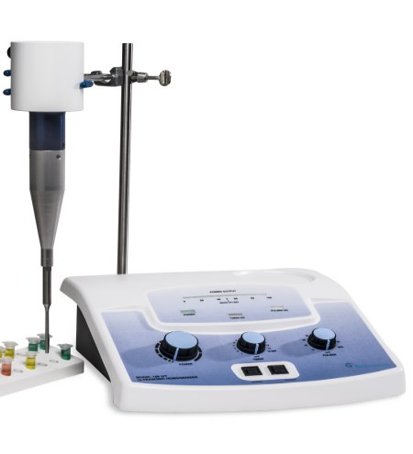 Fig.9.: Ultrasonic Homogenisers
Sonication is the act of applying sound energy via an ultrasonic bath or an ultrasonic probe to agitate particles in a sample. Sonication is used to disrupt cell membranes to release cellular contents, fragment molecules of DNA, homogenize "immiscible" liquids, accelerate enzymatic and chemical reactions, stimulate bacterial activity or remove dissolved gases from liquids by sonicating the liquid while it is under a vacuum. Disruption can be provided in continuous or pulse mode; models are available which can interface with a computer or be accessed remotely. The working frequency of sonicators is above hearing level to protect users. Look for features such as automatic control of sonotrode length and control of amplitude and time for reproducibility.

3.8 COOLING MICROCENTRIFUGE
A microcentrifuge is a laboratory instrument used to rapidly spin small volumes of samples at high speeds. It operates on the principle of centrifugation, which uses centrifugal force to separate particles of different densities or sedimentation rates in a liquid mixture.
Working Principle:
1. Sample Preparation: The liquid sample, often contained in small tubes called microcentrifuge tubes, is loaded into the rotor of the microcentrifuge. These tubes can hold volumes ranging from a few microliters to a few millilitres.
2. Rotor: The rotor is the part of the microcentrifuge that holds the sample tubes. It is designed to rotate at high speeds, creating centrifugal force that drives the separation process.
3. Acceleration and Deceleration: When the microcentrifuge is started, the rotor begins to accelerate, gradually increasing the rotational speed. Similarly, when the microcentrifuge is stopped, the rotor decelerates. Modern microcentrifuges are equipped with electronic controls to ensure smooth acceleration and deceleration, reducing the risk of sample disturbance or tube breakage.
4. Centrifugation: As the rotor spins at high speeds, the centrifugal force generated causes the components in the sample to separate based on their density. Heavier particles or components will move outward towards the bottom of the tube, while lighter components will move toward the top.
5. Pellet Formation and Supernatant: After centrifugation, denser components (such as cells, organelles, or precipitates) form a compact pellet at the bottom of the tube. The less dense components (such as supernatant or liquids) remain in the upper portion of the tube, forming the supernatant.
6. Collection and Analysis: Once centrifugation is complete, the tubes are carefully removed from the rotor. Depending on the application, researchers can collect and analyse either the pellet or the supernatant, depending on their specific research goals.

3.9 SOXHLET EXTRACTOR
A Soxhlet extractor is a piece of laboratory apparatus originally designed for the extraction of a lipid from a solid material. Typically, Soxhlet extraction is used when the desired compound has limited solubility in a solvent, and the impurity is insoluble in that solvent. It allows for unmonitored and unmanaged operation while efficiently recycling a small amount of solvent to dissolve a larger amount of material.
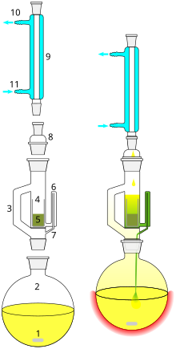
Fig.10: Diagramatic Soxhlet extractor
A Soxhlet extractor has three main sections: a percolator (boiler and reflux) which circulates the solvent, a thimble (usually made of thick filter paper) which retains the solid to be extracted, and a siphon mechanism, which periodically empties the condensed solvent from the thimble back into the percolator.
The solvent is heated to reflux. The solvent vapour travels up a distillation arm, and floods into the chamber housing the thimble of solid ensuring that any solvent vapour cools, and drips back down into the chamber housing the solid material. When the Soxhlet chamber is almost full, the chamber is emptied by the siphon. The solvent is returned to the distillation flask. The thimble ensures that the rapid motion of the solvent does not transport any solid material to the still pot.
During each cycle, a portion of the non-volatile compound dissolves in the solvent. After many cycles the desired compound is concentrated in the distillation flask. The advantage of this system is that instead of many portions of warm solvent being passed through the sample, just one batch of solvent is recycled. After extraction the solvent is removed, typically by means of a rotary evaporator, yielding the extracted compound. The non-soluble portion of the extracted solid remains in the thimble, and is usually discarded
3.10 PHOTO DIODE ARRAY
Photodiode arrays (semiconductor devices) are used in the detection unit. A DAD (Diode Array Detector) detects the absorption in UV to VIS region. While a UV-VIS detector has only one sample-side light-receiving section, a DAD has multiple photodiode arrays to obtain information over a wide range of wavelengths at one time, which is a merit of the DAD.
The idea is that spectra are measured at intervals of 1 second or less during separation by HPLC with continuous eluate delivery. If the measurement is performed at a fixed wavelength, components are identified from only their retention time; thus, a minor deviation in retention time can make identification of components difficult. In such a case, the DAD can be used to identify components by a comparison of the spectrum.
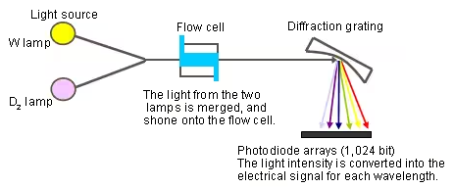
Fig.11: A DAD optical system.

DADs differ from UV-VIS detectors in that light from the lamps is shone directly onto the flow cell, light that passes through the flow cell is dispersed by the diffraction grating, and the amount of the dispersed light is estimated for each wavelength in the photodiode arrays.
Compared with a UV-VIS detector, the DAD has the following disadvantages: noise is large because the amount of light is small; the DAD is also susceptible to various changes, such as lamp fluctuations, because the reference light cannot be received. However, the DAD has recently been improved to reduce its difference in performance from UV-VIS detectors.

3.11. WATER BATH
A water bath is a laboratory device that works on the principle of indirect heating through conduction. It is designed to provide controlled and uniform heating to samples by immersing them in a bath of water.
Working Principle:
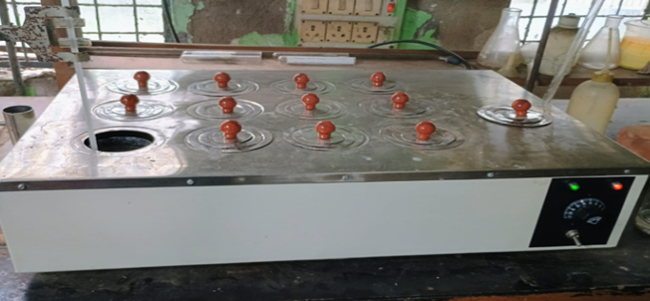
A typical water bath consists of a heating element at its base, usually electric, that warms the water within a reservoir or chamber. The water serves as the heat transfer medium. Users set the desired temperature on the built-in thermostat or digital controller.
Fig.12: Water bath
When the water bath is turned on and set to a specific temperature, the heating element heats the water in the reservoir. As the water warms up, it efficiently transfers heat to the containers or samples immersed in the bath. This indirect heating ensures that the samples are exposed to a consistent and uniform temperature, which is vital for numerous laboratory applications. The water bath's ability to maintain a stable temperature is essential in processes such as incubating cultures, thawing frozen samples, melting solid substances, or conducting chemical reactions that require precise temperature control.
To ensure safety and accuracy, many water baths come equipped with features like over-temperature protection and alarms to prevent overheating. Users can also monitor the bath's temperature through a built-in thermometer or an external probe.
Water baths are a fundamental tool in laboratories, especially in fields such as chemistry, biology, and medicine. They offer a straightforward yet effective method for heating samples without direct contact with a heating element, which is crucial for preventing overheating or temperature fluctuations that could compromise the integrity of sensitive materials or experimental results.
3.12. TLC VIEWING CABINET
TLC UV Cabinet is suitable for inspection thin-layer chromatogram and other object in a undarkened room. The front is closed with a magnetic lock, which can be pushed open. A glass filer in the viewing window protects the eyes against reflected short-wave UV light. Great care has been taken to ensure the correct distances between UV lamp, object and the observer’s eye in the interest of good illumination and untroubled viewing.
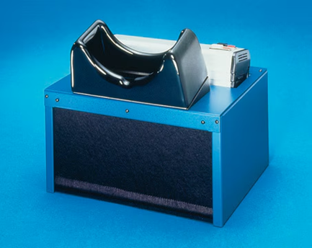Fig.13: TLC VIEWING CABINET
FEATURES AND BENEFITS :
Inspection of thin-layer chromatograms and other objects in an undarkened room.A glass filter in the viewing window protects the eyes against reflected short-wave UV light.
Base measures 370 x 300 mm inside.
For Visualization of test objectives under Tubes having long wave length (365nm), short wave length (254nm) as desired.
Use with ultraviolet lamp for Observing fluorescent effect chromatographs etc.
Supplied with 3 tubes to work on 230 volts A.C.only.
Provides and enclosed viewing space which eliminates external light interference.
Control switches mounted on top of the unit. This self-contained unit is designed for easy viewing and making of chromatographs. Minimum space requirements through reduced footprint
4. Chromatographic Techniques
Chromatography is a laboratory technique for the separation of a mixture into its components. The mixture is dissolved in a fluid solvent called the mobile phase, which carries it through a system (a column, a capillary tube, a plate, or a sheet) on which a stationary phase material is fixed. Because the different constituents of the mixture tend to have different affinities for the stationary phase and are retained for different lengths of time depending on their interactions with its surface sites, the constituents travel at different apparent velocities in the mobile fluid, causing them to separate. The separation is based on the differential partitioning between the mobile and the stationary phases.
Chromatography may be preparative or analytical. Preparative chromatography aims to isolate and purify specific components from a mixture for future use, often at a higher cost due to the scale of production. Analytical chromatography, on the other hand, involves smaller sample sizes and is used to identify and quantify the components present in a mixture.

4.1 TLC (THIN LAYER CHROMATOGRAPHY)
Thin Layer Chromatography is a technique used to isolate non-volatile mixtures. The experiment is conducted on a sheet of aluminium foil, plastic, or glass which is coated with a thin layer of adsorbent material. The material usually used is aluminium oxide, cellulose, or silica gel.
On completion of the separation, each component appears as spots separated vertically. Each spot has a retention factor (Rf) expressed as:
Rf = dist. travelled by sample / dist. travelled by solvent
TLC system consists of:
1.TLC plates: Preferably ready-made TLC plates with a stationary phase These plates, which have a thin layer of stationary phase applied to their whole surface, are stable and chemically inert. The stationary phase is in a fine particle size and has a consistent thickness on the plates.
2.TLC chamber: This is employed in the creation of TLC plates. For the appropriate development of spots, the chamber maintains a consistent atmosphere inside. Additionally, it maintains the process dust-free and stops solvent evaporation.
3.Mobile phase: This consists of a solvent or a mixture of solvents. For proper TLC spot development, the mobile phase utilized should be particle-free and of the greatest purity. The solvents should have no chemical reaction with the stationary phase of the sample.
4. Filter paper: Used for chamber saturation. For placement inside the chamber, this is wet during the mobile phase. This aids in the development of a uniform rise in the mobile phase throughout the stationary phase and avoids the tailing effect.
TLC For Rutin Trihydrate:
Procedure:
- For the mobile solvent phase, we prepare Ethyl acetate: Formic acid: And glacial acetic acid: Water in a 100:11:11:27 ratio in an Eppendorf tube.
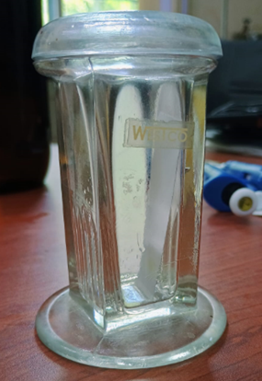
- This is poured into a TLC chamber and a tissue strip is inserted into the chamber. This helps the tissue to soak up all the solvent meanwhile also saturating the chamber with solvent vapours. This also prevents the tailing effect, during the process.
[Fig.14: TLC Chamber]
- A solution of Rutin in methanol is prepared and with the help of a capillary tube, a drop of it is put on a silica-coated alumina strip.
- TLC is run until 90% of the strip is covered in the solvent.
- The strip is taken out and the solvent front is marked.
- The strip is visualized under TLC-UV Visualizer and the solute front is marked.

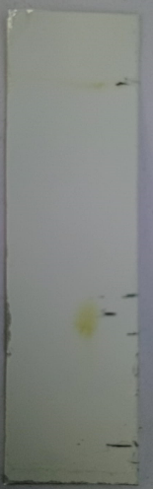

- Thereafter, the R_{f} is calculated.
R_{f} = Solute front = 1.8 = 0.4
Solvent front 4.5

Therefore, the Retention factor for rutin is 0.4 .
[Fig.15: TLC Strip]

Observation:
For better observation, iodine is blown onto the strips and the solute obtains a brownish spot, which is again observed as the solute front.
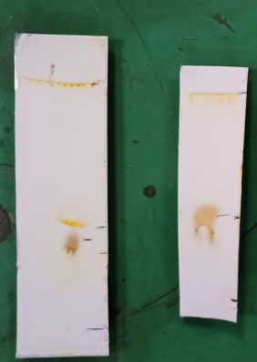 [Fig.16: TLC stained strip]
4.2 HPLC (HIGH-PERFORMANCE LIQUID CHROMATOGRAPHY)
High-performance liquid chromatography (HPLC), formerly referred to as high-pressure liquid chromatography, is a technique in analytical chemistry used to separate, identify, and quantify specific components in mixtures. The mixtures can originate from food, chemicals, pharmaceuticals, biological, environmental and agriculture, etc., which have been dissolved into liquid solutions.
Reversed-phase liquid chromatography (RP-LC) is the most common type of HPLC. It has a non-polar stationary phase and an aqueous, moderately polar mobile phase. In the reversed-phase methods, the substances are retained in the system the more hydrophobic they are. For the retention of organic materials, the stationary phases, packed inside the columns, are consisted mainly of porous granules of silica gel in various shapes, mainly spherical, at diameters 2 um, with varying pore diameters on whose surface are chemically bound C18 hydrocarbon.
Components of HPLC:
Stationary Phase: C18 silica(Octadecylsilane) column (More Polar)
Mobile Phase: Acetonitrile (A)/water (B) and each solvent, filtered through a 0.2μm pore size hydrophilic polypropylene filter
Pressure: Less than 4900 psi
Injector: Hamilton syringe
Pump: Reciprocating pump
Detector: UV-Vis
HPLC PROTOCOL:
- Purging: Cleaning the pipes with mobile phase to remove any air bubble, bypassing the column; at a rate of 8ml/min.
- Washing: Cleaning the columns with mobile phase to remove any previous mobile phase used.
- Set the method on LC Software: Set the method in which the pump runs, the pressure, through the LC Method File from the LC Data File, which was set to Binary Programme.
- Injection: The analyte(40µl) is collected in a Hamilton syringe, the injection port is turned to “Load”, the analyte is injected and then turned to “Inject”.
- Detection: A photomultiplier tube (PMT) amplifies the signals and Photo Diode Array (PDA) gives a spectrum from which the analyte chooses its own absorption maxima, which is 254nm for Rutin trihydrate.
DETECTION:
Rutin Trihydrate Rich Fraction at 254nm:
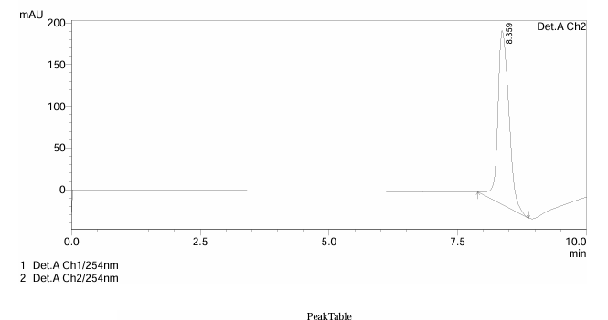
[Fig.16: HPLC graph for Rutin trihydrate]
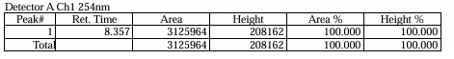
Hence, we conclude Rutin trihydrate to be 60% pure, from HPLC calculations.

5. Serial Dilution Of Rutin Trihydrate
Serial dilution is a scientific method for gradually lowering a substance's concentration in a solution. To generate solutions with known concentrations or to count the number of organisms in a sample when they are too numerous to count directly, it is frequently used in chemistry, microbiology, and other scientific disciplines.
- A concentrated stock solution of 1mg/ml of Rutin Trihydrate in methanol is prepared.
- Stock solution is diluted 7 times where it contains 1:9 ratio of stock and methanol respectively, in an Eppendorf tube. Suppose it is labeled as ‘D1’.
- 3.D1 contains 1000 μg/ml concentration. D1 is diluted into 1:1 ratio into another test tube where 1ml of D1 is added with 1ml of methanol named as D2; so it becomes 500μg/ml in D2.
- Similarly, 4 more times it has been repeated in 5 eppendorf tubes, dilution proceeds with a 1:1 ratio.
- Concentration of the series as follows:
Conc.(µg/ml) | 500 | 250 | 125 | 62.5 | 31.25
O.D at 230nm | 1.174 | 1.140 | 0.953 | 0.660 | 0.3
6. 200μl of the dilutions from each Eppendorf was taken and put in identical wells in a 96-well plate and absorbance at 230nm was measured for each well plate under a UV-Vis Spectrophotometer, and their decrease in concentration was noted through a graph below, which states that absorbance decreases with decreasing concentration and vice-versa
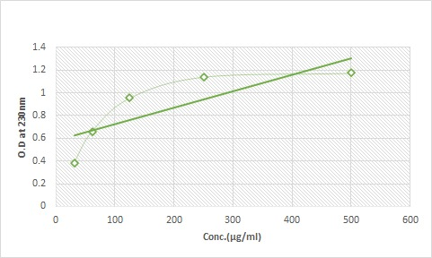 [Fig.17: Serial dilution graph]
6. Antioxidant Effect of Rutin Trihydrate

AIM: Assessment of antioxidant activity of Rutin trihydrate and comparison with standard by DPPH reduction method.

INTRODUCTION: Antioxidant compounds have the capability of acting as free radical scavengers providing various protective and beneficial health effect. Different methods are available for in vitro measurement and comparison of the activity of antioxidant compounds. The 2,2-diphenyl-1-picrylhydrazyl method depends mainly on the reduction reaction that occurs on the compound DPPH when it is reacted with a compound having an antioxidant capacity. [A= API= Rutin trihydrate].

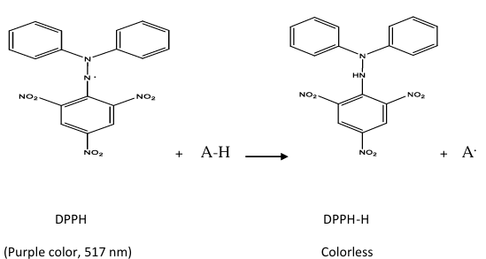
[Fig.18: DPPH reaction]

DPPH is a compound with a purple colour having an intense absorption at 517nm wavelength. The antioxidant capacity of a specific antioxidant compound can be estimated by tracking the reduction in the absorbance measurements, that results when different concentrations of the antioxidant agent are added to the DPPH solution.
III. PROCEDURE:
- Prepared 3mg/ml of Rutin in methanol, since Rutin dissolves better in methanol and serially diluted the above stock up to 7.81µg/ml.
- Similarly, ascorbic acid (taken as standard) stock solution is prepared as 3mg/ml and diluted till 7.81µg/ml.
- A solution of DPPH of concentration 0.002%w/v was freshly prepared.
- Samples of rutin and ascorbic acid were prepared by mixing DPPH, methanol and previously prepared working solutions in a ratio of 1:1:1 respectively.
- Methanol was used as the control along with DPPH in 2:1 ratio.
- All samples were kept in the dark for 30 minutes and the ansorbance was measured thereafter at 517nm wavelength.
- The percentage inhibition of each concentration of both the stocks were calculated according to the equation:
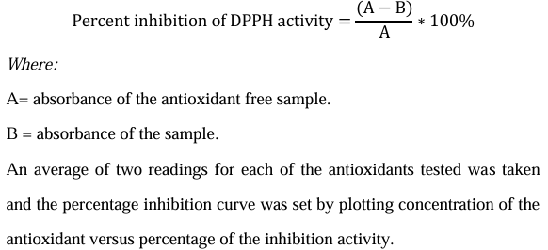

IV. RESULTS:
Concentration(µg/ml) | Rutin trihydrate | Ascorbic acid
 | %inhibition | %inhibition
3.95 | 17.34 | 19.87
7.9 | 36.87 | 37.98
15.625 | 42.46 | 52
31.25 | 58 | 74.8
62.5 | 74.5 | 78.5

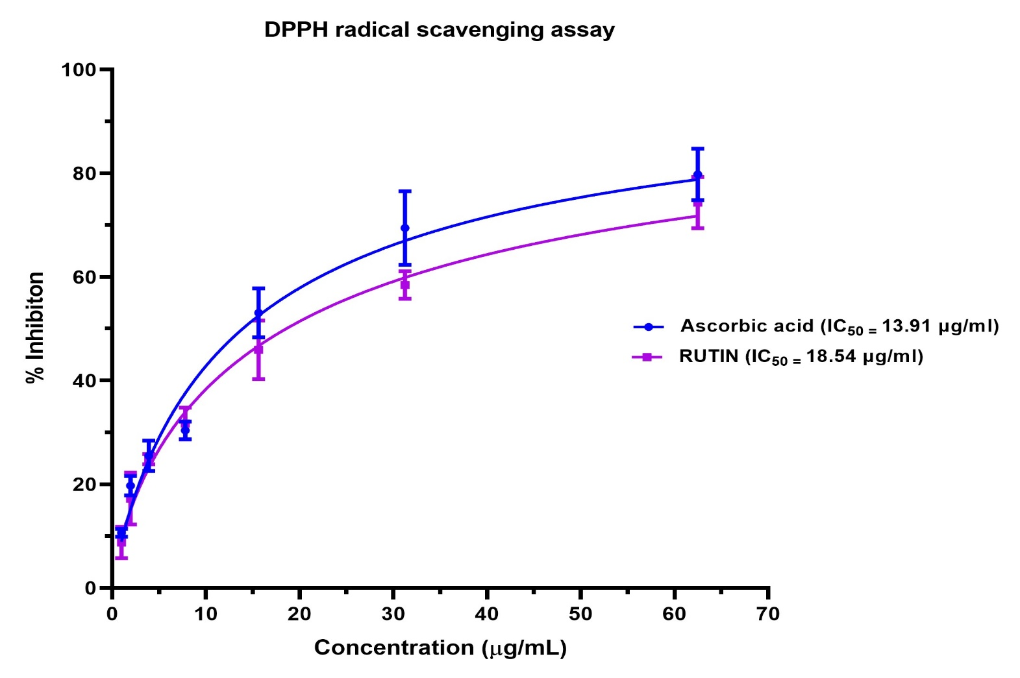
Fig.19: Rutin-DPPH Assay

7. Anti-inflammatory Effect of Rutin Trihydrate
I. AIM: Assessment of anti-inflammatory activity of Rutin trihydrate against the BSA Denaturation assay.
II. INTRODUCTION:
Bovine serum albumin (BSA), when subjected to heat, undergoes denaturation and initiates the expression of the antigen-associated response. The anti-denaturation assay is evaluated as a significant method for stabilizing compounds against allergies.
BSA is a protein, which denatures against an antigen-associated response to produce inflammation in that area. The drug, rutin ensures the inhibition of denaturation of BSA protein, to prevent unnecessary inflammation. This is measured by an assay, using PBS Buffer and Diclofenac as standard.
III. PROCEDURE:
- Phosphate Buffer Saline (PBS) Buffer was prepared by dissolving Sodium hydrogen phosphate and Potassium hydrogen phosphate in 50ml of water and pH was corrected to 6.3.
- Various concentrations of Rutin trihydrate and Diclofenac (as standard) were prepared using serial dilution in PBS Buffer (1000µg/ml to 7.89µg/ml).
- 1% BSA was prepared in PBS Buffer.
- In a 96-well plate, 225µl of BSA and 25µl of diluted Rutin was added and same was followed for Diclofenac.
- The well plate was incubated at 37⁰C at 4%CO₂; followed by heating at 70⁰C for 5 minutes in a water bath.
- It was allowed to cool down.
- Absorbance was measured at 660nm.
% Inhibition = $\frac{Control-Sample}{Control}*100\%$

IV. RESULTS:
Concentration(µg/ml) | Rutin trihydrate | Diclofenac
 | %inhibition | %inhibition
15.625 | 17.43 | 9.87
31.25 | 28.47 | 19.87
62.5 | 32.43 | 23.45
125 | 48 | 34.45
250 | 65.47 | 47.46
500 | 78.2 | 67.5

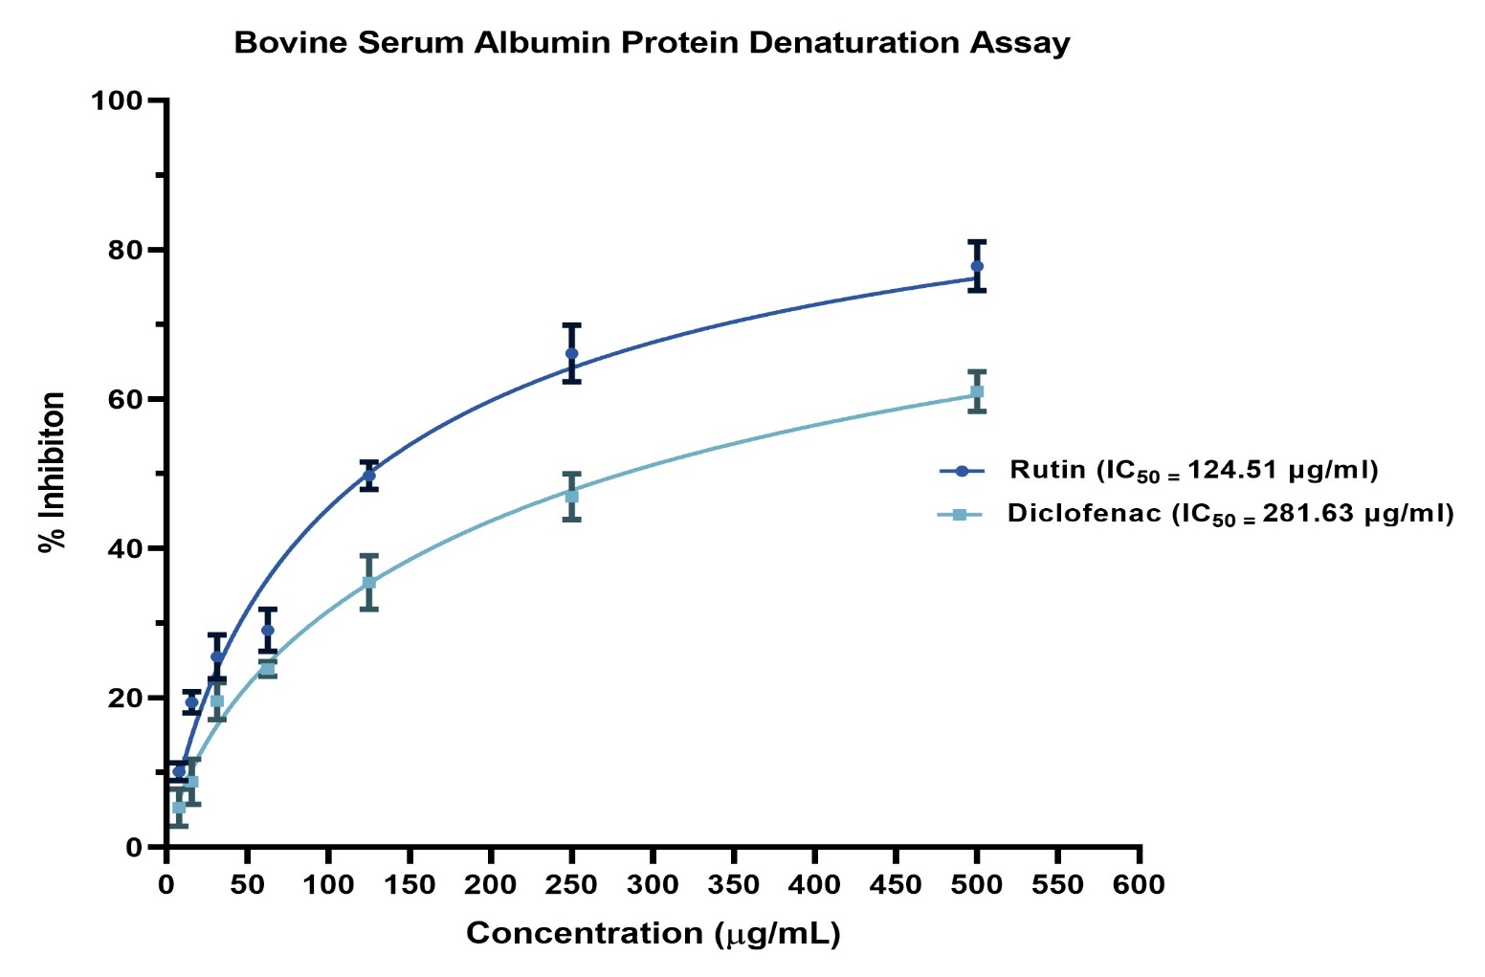
Fig.20: Rutin- Anti-inflammatory Assay

8. Antimicrobial Effect of Rutin Trihydrate
I. AIM: Assessment of antimicrobial activity of Rutin trihydrate against E.coli and B.subtilis.
II. INTRODUCTION:
- E.coli: Escherichia coli is a gram-negative, facultative anaerobic, rod-shaped, coliform bacterium of the genus Escherichia that is commonly found in the lower intestine of warm-blooded organisms. Most E. coli strains are harmless, but some serotypes such as EPEC, and ETEC are pathogenic and can cause food poisoning in their hosts, responsible for food contamination. The bacterium can be grown and cultured easily and inexpensively in a laboratory setting and has been intensively investigated for over 60 years.

- B. subtilis: Bacillus subtilis, is a gram-positive, catalase-positive bacterium, found in soil and the gastrointestinal tract of ruminants, humans and marine sponges. A 2009 study compared the density of spores found in soil (about 106 spores per gram) to that found in human feces (about 106 spores per gram). B. subtilis has become widely adopted as a model organism for laboratory studies, especially of sporulation, which is a simplified example of cellular differentiation. In terms as a laboratory model organism, B. subtilis is often considered as the Gram-positive equivalent of Escherichia coli, an extensively studied Gram-negative bacterium.

- Antimicrobial activity: An antimicrobial is an agent that kills microorganisms (microbicide) or stops their growth (bacteriostatic agent). Antimicrobial phytochemicals fall into several categories: phenolics/polyphenols, terpenoids, alkaloids, and lectins, etc. Phenolic and polyphenols are capable of forming an irreversible complex with nucleophilic amino acids in protein, leading to their inactivation also reported to disrupt microbial membranes, inactivate microbial enzymes, and activate immune response by stimulating macrophages.

III. METHODOLOGY:
A) Preparation of Stock Soln of API:
i) A concentrated stock solution of 3 mg/ml of Rutin Trihydrate in methanol is prepared, so that when 1ml is poured in a well, with 1ml of Media and 1ml of Inoculum, the concentration of the API in the well automatically becomes/ml.
ii) The API is serially diluted 6 times in water, to maintain the human body conditions; till the concentration reaches 15.625µg/ml. These concentrations are individually used for checking at which concentration, the maximum bacteriostatic/bacteriocidal effect is obtained.
B) Preparation of Media:
Media preparation in microbiology is a crucial step in cultivating and studying microorganisms, including bacteria, fungi, and other microorganisms. Microbiologists use various types of growth media to provide essential nutrients and conditions necessary for the growth of specific microorganisms. Here, liquid media known as Luria Bertani Broth is used, as it has more absorption capacity.
Ingredients:
1. 10 grams of Tryptone.
2. 5 grams of yeast extract.
3. 10 grams of Sodium chloride (table salt).
4. 1 litre of distilled or deionized water.
Procedure:
- Measure out the specified amounts of tryptone, yeast extract, and sodium chloride accurately using a balance.
- Add the tryptone, yeast extract, and sodium chloride to a large beaker.
- Pour the distilled or deionized water into the container while stirring continuously to dissolve the ingredients. Ensure that these components are completely dissolved to create a homogenous solution.
- Check the pH of the solution using a pH meter. The pH should be around 7.0, which is adjusted by using hydrochloric acid (HCl) or sodium hydroxide (NaOH).
- Pour the medium into bottles or flasks, making sure not to fill them to the top to allow for expansion during sterilization. Close the containers loosely with caps or aluminium foil.
- Sterilize the medium by autoclaving at 121 °C (250 °F) at 15 psi for approximately 15-20 minutes.
- Cooling: After autoclaving, allow the medium to cool down to room temperature. It should be in a liquid state.
- Dispense the liquid LB broth into sterile bottles, flasks, or test tubes, depending on your experimental needs. Ensure these containers are sealed tightly with caps or closures.
- Store the prepared LB broth appropriately. Keep it at room temperature if you plan to use it within a short period. For longer-term storage, refrigerate the broth and is replenished every 2-3months and stored in Biju bottles.
LB broth can be used for bacterial culture, growth, and maintenance. It can also be solidified with agar (usually 1.5-2% agar) to make LB agar plates for bacterial isolation and enumeration.
C) Preparation of Slant:
A slant medium is a type of solid microbiological growth medium that is prepared in a slanted tube or test tube. Slants are commonly used for the maintenance and storage of microbial cultures over extended periods.
Procedure:
- Prepare the slant medium including agar, peptone, and other nutrients, depending on your microorganism's requirements. Adjust the pH if necessary.
- Pour the prepared slant medium into test tubes, filling them to about one-third to one-half full. Cap the tubes loosely (loosen the caps slightly) to allow for steam sterilization. Sterilize the tubes containing the slant medium in an autoclave or pressure cooker at 121°C (250°F) at 15 psi for about 15-20 minutes.
- After autoclaving, remove the tubes from the autoclave, and while the medium is still hot and liquid, carefully tilt the tubes at an angle to create a slanted surface by resting the tubes at an angle in a test tube rack or by using a specialized slanting device. Allow the medium to solidify while still at an angle.
- Allow the slant medium to cool and solidify at the slanted angle. This creates a larger surface area for microbial growth.
- Storage: Once the slant medium has cooled and solidified, store the tubes in an upright position in a cool, dark place or a refrigerator. Label each tube with important information, including the date of preparation, medium type, and any other relevant details.
Slant media are particularly useful for maintaining pure cultures of microorganisms over an extended period. When needed to use the culture, we can easily streak it onto a fresh agar plate or use it to inoculate liquid media for further experiments. Proper labelling and record-keeping are essential to track the cultures stored in slants.
E) Preparation of Mc Farland Standard:
McFarland standards are used as a reference to adjust the turbidity of bacterial suspensions so that the number of bacteria will be within a given range to standardize microbial testing. An example of such testing is antibiotic susceptibility testing by measurement of minimum inhibitory concentration which is routinely used in medical microbiology and research. If a suspension used is too heavy or too dilute, an erroneous result (either falsely resistant or falsely susceptible) for any given antimicrobial agent could occur.
McFarland standards were made by mixing specified amounts of barium chloride and sulfuric acid. Mixing the two compounds forms a barium sulfate precipitate, which causes turbidity in the solution. A 0.5 McFarland standard is prepared by mixing 0.05 mL of 1% anhydrous barium chloride, with 9.95 mL of 1%(v/v) sulfuric acid (H2SO4). 0.9% NaCl is added for isotonicity. The tubes were sealed and kept in a refrigerator.

Standard tube numbers | 1%BaCl2(ml) | 1%HCl(ml) | Corresponding bacterial concentration(million/ml)
0.5 | 0.05 | 9.95 | 150
1.0 | 0.1 | 9.9 | 300
2.0 | 0.2 | 9.8 | 600
3.0 | 0.3 | 9.7 | 900
4.0 | 0.4 | 9.6 | 1200
5.0 | 0.5 | 9.5 | 1500

D) Inoculating Bacterial Culture:
Inoculating a bacterial culture involves transferring a small, sterile portion of a pure bacterial sample onto a fresh growth medium, such as agar or liquid broth.. Using a sterilized loop or pipette for liquid broth and a striker for Agar plate, aseptic technique is employed to prevent contamination. The culture is gently streaked or pipetted onto the medium's surface, ensuring even distribution. Proper labeling and documentation are essential to track the culture's identity and growth conditions. If inoculated, turbidity is observed after 24 hrs.
➢ Inoculating Escherichia coli and Bacillus subtilis:
Procedure:
- Flame the workspace to create an updraft to minimize airborne contaminants. Wear sterile gloves and a lab coat to maintain aseptic conditions.
- Ensure that slant tubes are properly prepared, cooled and solidified at an angle, as explained in the previous response.
- Flame-Sterilize the Inoculating Loop or Pipette: Hold the inoculating loop or pipette over the flame of a Bunsen burner or alcohol lamp until it turns red-hot. This sterilizes the instrument.
- Inoculums were diluted in sterile normal saline and turbidity was measured with 0.5 Mc Farland standard.
- Inoculate the Slant: Lift the cap of the slant tube with your free hand, and use the sterilized loop of 2mm diameter to streak the E. coli culture onto the surface of the slant medium. Start at the top of the slant and make a streak down the slant in a zigzag pattern, ensuring even distribution of the bacteria. Close the cap of the tube immediately to prevent contamination.
- Label the Slant Tube using labelling tape to label the slant tube with important information, including the date of inoculation, the strain of E. coli, and any other relevant details.
- Incubation: Place the inoculated slant tube in an incubator at the appropriate temperature for E. coli growth, typically around 37 °C (98.6 °F).
F) Determination of MIC and MBC:
The broth microdilution technique was used to determine the MIC values of the Rutin trihydrate against various microbial strains. The samples were diluted twice in a 96-well plate to generate serial dilutions with concentrations ranging from 3.9 to 1000 μg/mL.. The diluted medium was added with 100 μL of the inoculum containing approximately 106 CFU/mL of each strain. 0hr readings were taken and after 24h of incubation at 37◦C, the MIC was determined as the lowest concentration of naringin at which the bacteria did not show observable growth. Turbidity suggested that there was bacterial growth. To determine MBC, on LB agar medium, 100 μL of the previously grown medium up to MIC concentration were plated and incubated for 24 h at 37 ◦C. MBC of rutin is the lowest concentration at which no microbe could survive.
IV. RESULTS:
- For Escherichia coli:

Rutin conc.(µg/ml) | 1000 | 500 | 250 | 125 | 62.5 | 31.25 | 15.625 | 7.81 | 3.9
0hr reading | 0.075 | 0.067 | 0.093 | 0.091 | 0.077 | 0.075 | 0.074 | 0.074 | 0.073
24hr reading | 0.180 | 0.192 | 0.675 | 0.669 | 0.632 | 0.612 | 0.613 | 0.616 | 0.615

Here, we conclude that 500µg/ml of Rutin shows a Bacteriostatic effect, which is considered to be the MIC (Minimum Inhibitory Concentration). 2MIC = MBC = 1000µg/ml, which is the Minimal Bactericidal Concentration

At 500µg/ml, we conclude from the graph that it shows a Bacteriostatic effect from 900s – 11700s. Therefore, we conclude that Rutin trihydrate is a Bacteriostatic API at 500µg/ml for E. coli (a Gram -ve bacteria).
- For Bacillus subtilis:

Rutin conc.(µg/ml) | 1000 | 500 | 250 | 125 | 62.5 | 31.25 | 15.625 | 7.81 | 3.9
0hr reading | 0.101 | 0.082 | 0.093 | 0.078 | 0.076 | 0.078 | 0.077 | 0.069 | 0.068
24hr reading | 0.637 | 0.456 | 0.384 | 0.376 | 0.437 | 0.340 | 0.288 | 0.596 | 0.342

Here, we can observe fluctuating readings where the bacterial concentration is high at a higher concentration of rutin, whereas for a lower concentration of rutin, the bacterial concentration is low. This should not be the case for a Bacteriostatic or Bacteriocidal API. Therefore, we conclude that Rutin trihydrate for B. subtilis, a Gram +ve bacteria, is neither a Bacteriostatic nor a Bacteriocidal API.
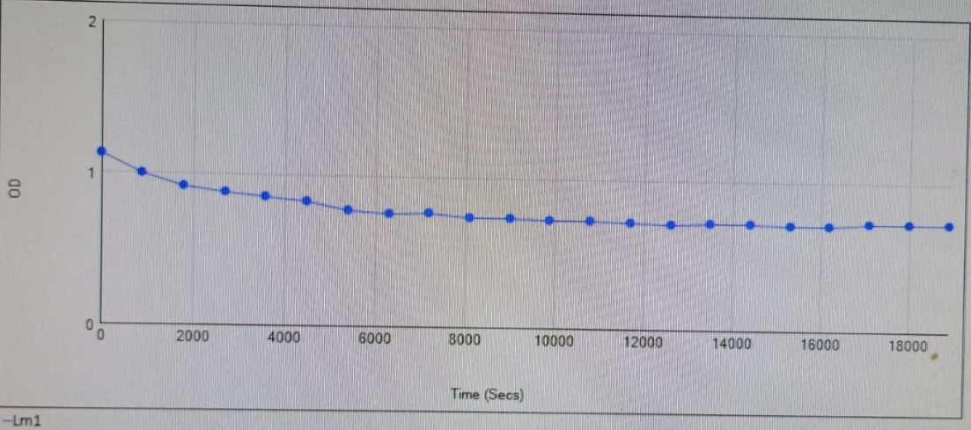
Fig.21: Rutin- Anti-microbial activity

Bacteriocidal activity begins from 0sec-8000sec, after which the drug again becomes Bacteriostatic.

9.Conclusion

In conclusion, our study successfully characterized Rutin trihydrate using HPLC and TLC techniques, confirming its presence and purity. Furthermore, our in vitro assays demonstrated Rutin's significant antioxidant, anti-inflammatory, and antimicrobial potential.
The results suggest that Rutin trihydrate may be a valuable compound for the development of natural-based products with therapeutic applications, such as wound healing, anti-aging, and antimicrobial agents. The antioxidant and anti-inflammatory activities of Rutin trihydrate make it a promising candidate for the prevention and treatment of chronic diseases. Additionally, its antimicrobial properties indicate potential uses in the pharmaceutical and food industries.
Experiments were repeated multiple times to establish the accuracy of the procedures performed and reduce human error. Good Laboratory Practices were followed at all times.
Further, in vivo studies and clinical trials are necessary to fully explore the therapeutic potential of Rutin trihydrate. Our findings contribute to the growing body of research on the bioactive properties of Rutin trihydrate and its potential applications in healthcare and industry.

10. References

- https://journal.pan.olsztyn.pl/DETERMINATION-OF-THE-ANTIOXIDANT-ACTIVITY-OF-RUTIN-AND-ITS-CONTRIBUTION-TO-THE-ANTIOXIDANT,98275,0,2.html#:~:text=For%20the%20measurement%20of%20the,100%20%C2%B5mol%2FL%2C%20respectively.&text=1.,Chemical%20structure%20of%20rutin.

- TALA_SARHAN_RUTIN-THESIS_-FINAL_(_EXAMINERS___EDITIONS)[1].PDF

- [Professor_Dr._Hildebert_Wagner,_Dr._Sabine_Bladt,(z-lib.org)[1].pdf

- https://www.ncbi.nlm.nih.gov/pmc/articles/PMC4177624/

